NCA & CDT Baby & Toddler Fund raiser; Feb 15, 2023

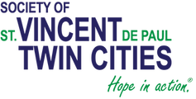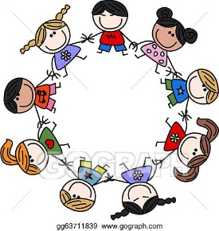
- accepting Gently used or new: Baby/toddler clothes, toys, books, linens. (Think about thrift stores when shopping)
- Also accepting New: Diapers, formula, baby/toddler food, hygene products, bottles, bibs, burp cloths, pacifiers; etc.

NCA & CDT Baby & Toddler Fund raiser; Feb 15, 2023

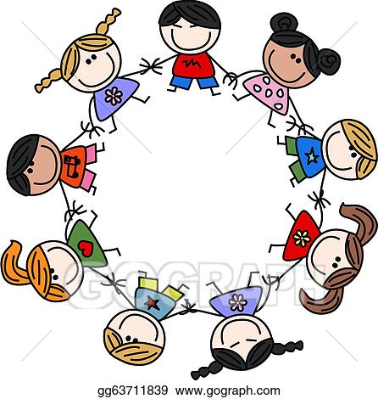
- accepting Gently used or new: Baby/toddler clothes, toys, books, linens. (Think about thrift stores when shopping)
- Also accepting New: Diapers, formula, baby/toddler food, hygene products, bottles, bibs, burp clothes, pacifiers; etc.

